**Investigating Pulley Systems**

**Aim:** To examine the relationships between forces and distances in pulley systems.

**Equipment:** 2 single pulleys

2 double pulleys

1 metre length of string (with a loop tied in each end)

400g set of slotted masses (this is a load of approximately 4 N)

Set of spring balances

Retort stand

Boss head

Ruler

**Procedure:**

1. Connect the boss head to the retort stand so that the boss head is at the very top.
2. Hook a single pulley to the screw of the boss head.
3. Attach one end of the piece of string to the top of the mass holder and thread the other end through the pulley.
4. With a coloured texta, mark the string at the top of the pulley.
5. Attach the spring balance to the end of the string and pull on the balance slowly so that the load is lifted 10 cm upwards.
6. With the same coloured texta, mark the string at the top of the pulley a second time.
7. Record the effort force in your table.
8. Remove the string, measure and record the distance between the coloured marks. This is the effort distance.
9. Add another pulley to the system, using the diagrams to help and repeat steps 4 to 9 until you have 4 pulleys in the system.
10. Calculate the mechanical advantage of each pulley using the formula below

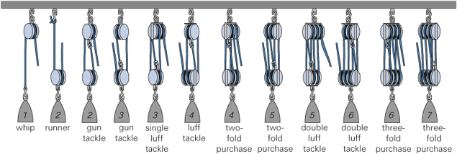

**Results:**

|  |  |  |  |  |  |  |  |  |
| --- | --- | --- | --- | --- | --- | --- | --- | --- |
| Number of Pulleys | Load (N) | Load Distance (cm) | Effort Distance (cm) | Effort 1 (N) | Effort 2 (N) | Effort 3 (N) | Average Effort (N) | Mechanical Advantage |
| 1 | 4 | 10 cm |  |  |  |  |  |  |
| 2 | 4 | 10 cm |  |  |  |  |  |  |
| 3 | 4 | 10 cm |  |  |  |  |  |  |
| 4 | 4 | 10 cm |  |  |  |  |  |  |

**Questions:**

1. On the grid below, construct a **column graph** to show the relationship between the number of pulleys and the mechanical advantage.

|  |  |  |  |  |  |  |  |  |  |  |  |  |  |  |
| --- | --- | --- | --- | --- | --- | --- | --- | --- | --- | --- | --- | --- | --- | --- |
|  |  |  |  |  |  |  |  |  |  |  |  |  |  |  |
|  |  |  |  |  |  |  |  |  |  |  |  |  |  |  |
|  |  |  |  |  |  |  |  |  |  |  |  |  |  |  |
|  |  |  |  |  |  |  |  |  |  |  |  |  |  |  |
|  |  |  |  |  |  |  |  |  |  |  |  |  |  |  |
|  |  |  |  |  |  |  |  |  |  |  |  |  |  |  |
|  |  |  |  |  |  |  |  |  |  |  |  |  |  |  |
|  |  |  |  |  |  |  |  |  |  |  |  |  |  |  |
|  |  |  |  |  |  |  |  |  |  |  |  |  |  |  |
|  |  |  |  |  |  |  |  |  |  |  |  |  |  |  |
|  |  |  |  |  |  |  |  |  |  |  |  |  |  |  |
|  |  |  |  |  |  |  |  |  |  |  |  |  |  |  |
|  |  |  |  |  |  |  |  |  |  |  |  |  |  |  |
|  |  |  |  |  |  |  |  |  |  |  |  |  |  |  |
|  |  |  |  |  |  |  |  |  |  |  |  |  |  |  |
|  |  |  |  |  |  |  |  |  |  |  |  |  |  |  |

1. Describe the relationship between the number of pulleys and the effort used to lift the load.
2. Describe the relationship between the number of pulleys and the mechanical advantage.
3. Describe the relationship between the number of pulleys and the distance the effort moves.
4. The effort needed to lift the load using a single pulley is the same as lifting it straight up. Explain why a single pulley is still useful.
5. Predict the effort that would be needed to lift the load with five pulleys. Predict how far you will need to pull the string.